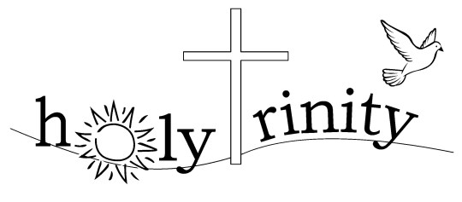
www.holytrinitybs.com

Annual Meeting of Parishioners for the Parish of Holy Trinity,
Bishop’s Stortford held on Zoom on Friday 18th September 2020 at 7.00 pm.

Rev’d Canon Mandy welcomed everyone to the meeting.

- Appointment of Secretary for the meeting: Michelle

- An attendance register was taken, 20 persons present (plus the Chairman).

Apologies for absence were received from: Camilla Brown
Mandy Hathaway
James Martin
Jean Neyts
Carole Read
Lucy Riley
Audrey Smith
Belle Snelle
Isy Watson
John Wrentmore

- Approval of the minutes of the meeting held on Sunday 7th April 2019 was proposed by Sam Clayden and seconded by Sheila Ballisat. They were then signed by the Chairman.

- Election of Churchwarden:

Gillian Micallef proposed by Roy Brown seconded by David Perry

There were no further nominations. The Chairman declared Gillian elected as Churchwarden. There was unanimous approval.

- Mandy thanked Sheila for clearing the Memorial Garden.

- The meeting closed at 7.17 pm

Signed ……………………………….

Date ……………………………….

